Brandywine Homes — Veeam Backup for Microsoft 365
Monthly Backup Report — 2026-04
M365 tenant: brandywinehomes.onmicrosoft.com
Report generated: 2026-05-02 18:21
Executive Summary
115 M365 users in this tenant are protected by Veeam Backup for Microsoft 365. Total backup storage in use is 4.76 TB across 1 repository, with 1 active backup job. This report breaks down storage by Microsoft 365 service, lists per-user backup coverage, and projects how storage will grow over the next 12 months.
115  M365 Users | 68  Users w/ OneDrive backed up | 4.76 TB  Backup Storage Used | 1  Backup Jobs (Running)
Backup Posture
Job | Backup Type | Last Run | Status | Enabled | Next Run
BWH-O365 | EntireOrganization | 2026-04-29T02:49:13.1012406Z | Running | Yes | 2026-05-02T20:10:00Z
Backup repositories:
Repository | Used | Capacity | Free | Path
BWH-O365 | 4.76 TB | 6.00 TB | 1.24 TB | C:\O365 Backups\bkp_BWH-365

Storage by M365 Module
Per-module bytes are estimated by attributing the tenant's total used backup storage in proportion to how often each service appeared in restore points over the last 90 days, weighted by industry-default ratios. For exact per-mailbox / per-site sizes, run the VB365 PowerShell module (Get-VBOEntityData).
Module | Estimated Storage | Share of Total | RP coverage (last 90d)
Exchange | 2.84 TB | 59.6% | 475 / 496
OneDrive | 1.05 TB | 22.1% | 388 / 496
SharePoint | 678.81 GB | 13.9% | 407 / 496
Teams | 211.26 GB | 4.3% | 380 / 496
Per-User Backup Coverage
115 users in the M365 directory. Mailbox coverage is set Yes for every user when the job is EntireOrganization (current setting). OneDrive coverage is determined by probing /users/{id}/onedrives.
Display Name | Email | Mailbox | OneDrive
Doug McGaugh | doug@brandywine-homes.com | Yes | No
Joseph Hoffman | joseph@brandywine-homes.com | Yes | Yes
ILG1 | ILG1@brandywine-homes.com | Yes | Yes
Jody Matye | jody@brandywine-homes.com | Yes | Yes
Dennis Hendricks | dennis@brandywine-homes.com | Yes | No
Pon Manithip | pon@brandywine-homes.com | Yes | Yes
Mike Von Feldt | mike@brandywine-homes.com | Yes | Yes
Large Conference Room | largeconference@brandywine-homes.com | Yes | No
Julio Sanchez | Julio@brandywine-homes.com | Yes | Yes
Carson Landing5 | carsonlanding5@brandywine-homes.com | Yes | Yes
Brandywine Project Management | PM@brandywine-homes.com | Yes | No
Ryan Grexton | ryan@brandywine-homes.com | Yes | Yes
Licensing | licensing@brandywine-homes.com | Yes | No
Dave Barisic | dave@img-re.com | Yes | No
John Beebe | jbeebe@brandywine-homes.com | Yes | Yes
David Rea | david.rea@brandywine-homes.com | Yes | Yes
Ann Barisic | Ann@brandywine-homes.com | Yes | Yes
Karen Havens | khavens@brandywine-homes.com | Yes | Yes
Julia Matsumura | julia@brandywine-homes.com | Yes | Yes
Chris Courtney | chris@brandywine-homes.com | Yes | Yes
Peter Bertone | pbertone@brandywine-homes.com | Yes | No
Chris Lagomarsino | clagomarsino@brandywine-homes.com | Yes | Yes
Joseph Aranda | jaranda@brandywine-homes.com | Yes | Yes
Raul Contreras | raul@brandywine-homes.com | Yes | Yes
Paula Gruner | Paula@brandywine-homes.com | Yes | No
Daisy Tong | daisy@brandywine-homes.com | Yes | Yes
Ring Cameras | ring@brandywine-homes.com | Yes | No
Richard Martinez | richard@brandywine-homes.com | Yes | Yes
Lasso NDR Reports | lassondrreports@brandywine-homes.com | Yes | No
Accounts Payable | ap@brandywine-homes.com | Yes | No
Newstar Const | newstar@brandywine-homes.com | Yes | No
Sandy Zundell | sandy@brandywine-homes.com | Yes | Yes
Lesley Pennington | lesley@brandywine-homes.com | Yes | Yes
Alisal Sales | alisal@brandywine-homes.com | Yes | Yes
Customer Service | customerservice@brandywine-homes.com | Yes | No
Joseph Perri | jperri@brandywine-homes.com | Yes | Yes
Heather Hanson | heather@brandywine-homes.com | Yes | Yes
mail | mail@brandywine-homes.com | Yes | No
Conference Room 3 | conference3@brandywine-homes.com | Yes | Yes
Gables Sales | gables@brandywine-homes.com | Yes | Yes
Inform XL | informxl@brandywine-homes.com | Yes | Yes
Rosa Torres | rosa@brandywine-homes.com | Yes | Yes
Joy Ding | joy@brandywine-homes.com | Yes | Yes
RTHM Sales | rthm@brandywine-homes.com | Yes | No
Discovery Search Mailbox | DiscoverySearchMailbox{D919BA05-46A6-415f-80AD-7E09334BB852}@brandywinehomes.onmicrosoft.com | Yes | No
Jim Fortune (Shared) | jfortune@brandywine-homes.com | Yes | No
Mirasol Sales | mirasol@brandywine-homes.com | Yes | Yes
Accounting Temp | accounttemp@brandywine-homes.com | Yes | Yes
Persimmon Sales | persimmon@brandywine-homes.com | Yes | Yes
Sarah Eskandari | Sarah@brandywine-homes.com | Yes | Yes
… and 65 additional users (full list in data.json).

Storage Trend & Projection
Projection method: industry default 4% MoM (will refine after 2+ monthly snapshots). Compound monthly growth rate used: 4.00%.
Horizon | Projected Storage | Δ vs today
Today (snapshot) | 4.76 TB | —
+3 months | 5.35 TB | +608.51 GB
+6 months | 6.02 TB | +1.26 TB
+9 months | 6.77 TB | +2.01 TB
+12 months | 7.62 TB | +2.86 TB
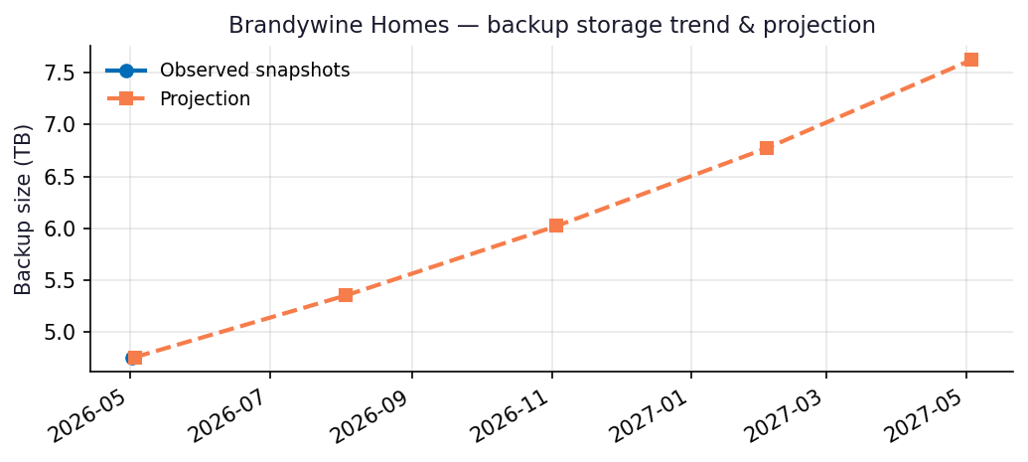
Recommendations
- Repository BWH-O365 is 79% full (1.24 TB free of 6.00 TB capacity).
- Capacity flag: Repository will hit ~90% utilization within 6 months at the current trend — begin capacity planning now.
- Run this report monthly. The projection accuracy improves with each snapshot — after 3 snapshots the linear-regression fit replaces the industry-default growth assumption.

Appendix: Methodology & Data Sources
Data sources
- Veeam Backup for Microsoft 365 REST API at https://10.7.9.227:4443/v8 (OAuth2 password grant; self-signed TLS).
- Endpoints used: /Organizations, /Organizations/{id}/usedRepositories, /Organizations/{id}/users, /Organizations/{id}/users/{uid}/onedrives, /BackupRepositories, /Jobs, /RestorePoints?backupTimeFrom=...
Per-module attribution caveat
REST does not expose per-mailbox or per-OneDrive backup byte counts on this build. Per-module estimates reweight the total used storage by the share of restore points (over the trailing 90 days) that included each service. Treat the numbers as informed estimates, not invoiced figures. For ground-truth per-user/per-team sizes use the VB365 PowerShell module Get-VBOEntityData.
Trend projection
- With <2 monthly snapshots: project at 4%/month compound.
- With ≥2 snapshots: linear regression on log(bytes) over time.

